**IOT PROJECT**

(2020-2021)

**IOT based real time covid precaution**

GROUP NO-6

**Midterm REPORT**



**Institute of Engineering & Technology**

**Department of Computer Engineering & Application**

**Team Members**

Mandavi Upadhyaya

(171500178)

Vivek Bhardwaj

(191599019)

Ranjan Kumar

(181500557)

**Supervised By**

Mr. Amir Khan

Asst. Professor

**Department of Computer Engineering & Applications**

**Contents**

1. Acknowledgment

2. Introduction

2.1 Motivation and overview

2.2 Objective

2.3 Scope

3. working model and result analysis

4. Layout

5. some screenshot

6. reason for selecting this project

7. References

**Chapter 1**

**ACKNOWLEDGEMENT**

I have taken efforts in this project. However, it would not have been possible without the kind support and help of many individuals. On the completion of this project I would like to extend my sincere thanks to all of them. I am highly indebted to this project guide **Mr Amir khan**, **Technical Trainer** for their guidance and constant supervision as well as for providing necessary information regarding the project. I wish to extend my sincere gratitude to **Prof. Anand Singh Jalal, Head of** **Department of Computer Engineering and Applications** and faculty of CEA Department of **GLA University** for their guidance, encouragement and give this opportunity and valuable suggestion which prove extremely useful and helpful in completion of this synopsis. I would also like to thank all those who directly or indirectly supported or helped me. I would like to express my gratitude towards my parents and member of my college for their kind cooperation and encouragement which helped me in completion of this project. All of them have willingly helped me out with their abilities.

**Chapter 2**

**2.1 Motivation and Overview:**

Internet of Things is a field of technology that describes the network of various “things” that is physical objects that are all embedded with different sensors, that are destined to measure various things or parameters such as temperature, humidity, distance, presence of an obstacle and many more. It also has the ability to transfer over a network using technologies like Cloud computing and fog computing. On such application of IOT the COVID precaution this was the major issue of now a day the hole world is worried about this disease this help people to prevent yourself.

* 1. **Objective:**

The real time covid precaution is an intelligent safety management and monitoring system. The basic objective of this project is made to develop a system model. It monitors and keep a look over the area in which it is installed using sensors

* 1. **Scope:**

Since we all are aware that these days COVID are rapidly increase the hole world are in danger because any medicine are not there all the people maintain social distancing , sanitizer and many more thing no any time of system keeping this in mind our team has develop an automated and intelligent IOT based system which would detect and immediately inform the owner of an unauthorized entry through a real time feedback system giving him the message notification on a mobile application which is a major module of a project.

**Chapter 3**

**Working model and result analysis**

**Working model**

The safety has always become the big necessity for the people. As there are rapid increments in the COVID patient.

For the safety purpose of the people to guarding ourselves, the system is proposed called “IOT based real time COVID precaution”.

It reduces the work of human for continuous checking of the distance from other people, wear mask and sanitize the hand this system is totally based on take precaution from COVID 19.

**In this project we using some components that are following:-**

**ARDUINO Uno-Mega:**

It is an open source electronics which is easy to use hardware and software.Arduino board are able read inputs and turn into o/p.We can tell our board what to do by sending instructions on the board.So, we need Arduino Programming Language(based on wiring) and Arduino Software(based on processing).

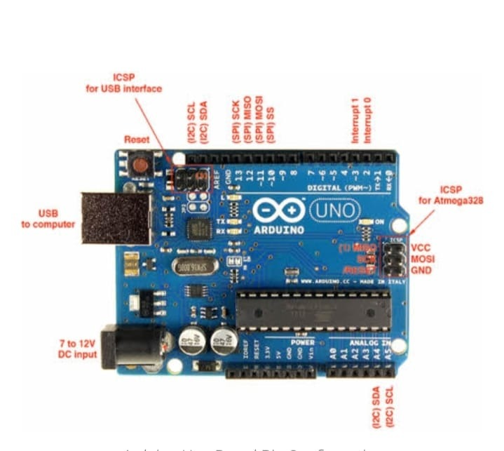

Arduino Uno pin configuration

**ESP8266-**

It is low cost Wi-Fi microchip,with full TCP/IP stack and micro-controller capability.

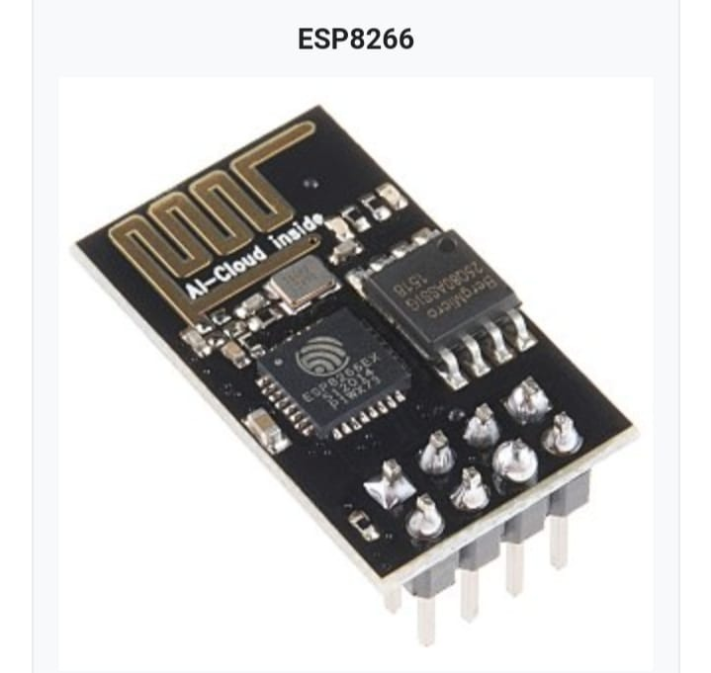

**BLYNK app-**

It is an app whether our Arduino,NodeMCU or Raspberry pi is linked with internet over Wi-Fi ,blynk can get us online which control hardware remotely.It create amazing interfaces for our project.Its sever communicate b/w phone and hardware.

**ULTRASONIC SENSOR:**

An ultrasonic sensor is an electronic device that measures the distance of a target object by using its component that are:-

1.)Transmitter (Trigger)

2.)Receiver (Echo)

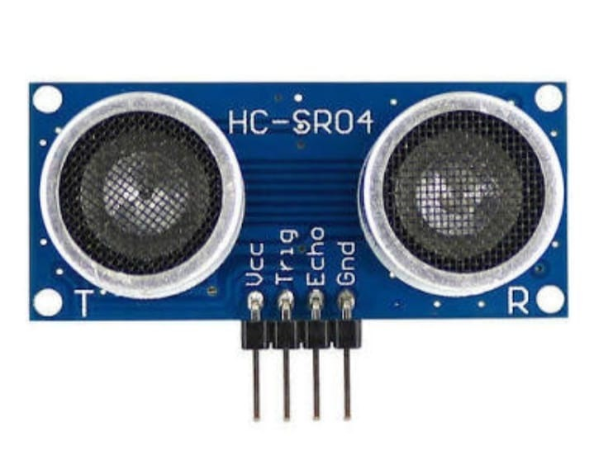

**Ultrasonic sensor working:-**

Ultrasonic sensor has 4 pin, whose pin names are Vcc, Trigger, Echo and Ground .

Vcc- The Vcc powers the sensor with +5v.

Trigger- It is input pin.

Echo- It is o/p pin.

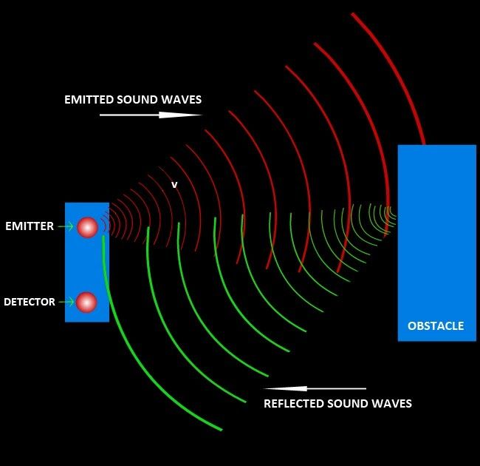

By emitting ultrasonic waves from trigger, and converts the reflected sound into a signal which is received by echo by which signal pass to the touch sensor if the target object is in ultrasonic range.

Basically it help to find the distance of target object.By using simple formula that we were using in high school:-

Distance=Speed* Time

Speed of US( At room condition)=330m/s

Time=TE (time to reach the wave to find target object) + TR(time to return the wave to US sensor).

**Feature of Ultra-Sonic sensor:-**

1. ) Frequency-40Hz
2. ) Distance- 2 to 400cm
3. ) Output voltage high when target is in range.

**Touch Sensor:**

It is a electronic sensor which is used in detecting physical touch.Also known as Tactile sensor,it is small,low cost,simple sensor.

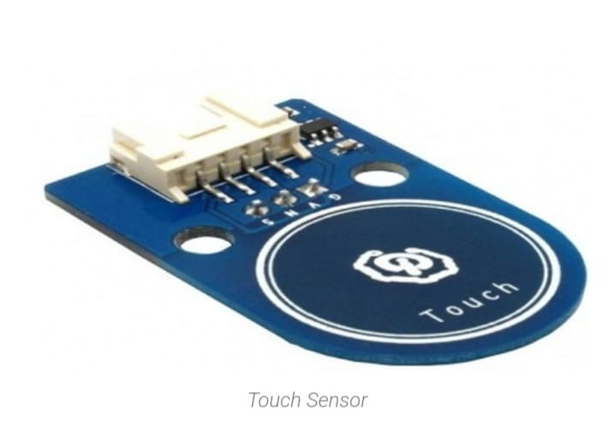

**How Touch Sensor Work-**

Touching the touch sensor through physically which causes signal will be generated. 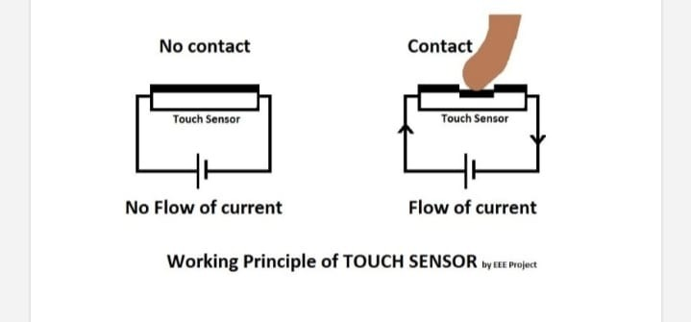

After receiving signal from US sensor,touch sensor check that physically it touches on particular spot or not.If it is then,it generate signal and pass to the PIR sensor.

**PIR SENSOR:**

It stands for Passive Infrared sensor which sense the IR light which are radiating from objects if object exist in its field.It is mostly used in to detect the motion object.

e.g-security alarm,home automation etc.

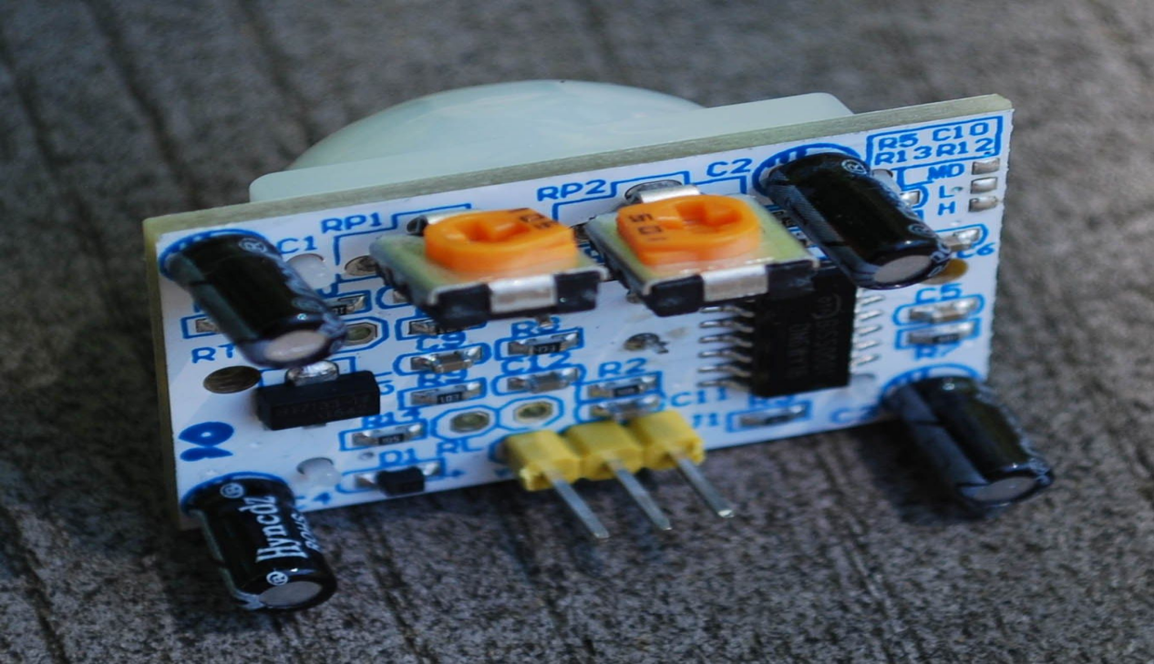

**How PIR Sensor work:-**

Whenever any moving object that generate heat(change in temperature in its body) in the range of this sensor it can immediate generate signal.

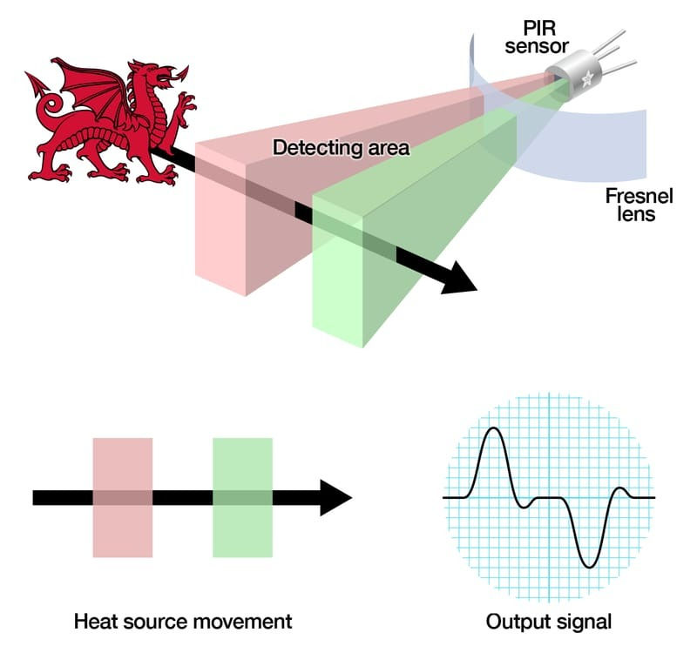

Receiving the signal from touch sensor,it check whether it is moving object or not,if it is then the signal pass to the Alcoholic sensor(MQ3).

**Mq3:**

It is a low cost semiconductor sensor which can detect the presence of alcohol gases.The

sensitive material used is SnO2 whose conductivity is lower than air.Its concentration is directly proportional to presence of alcohol in air.It has good sensitivity to alcohol in wide range.

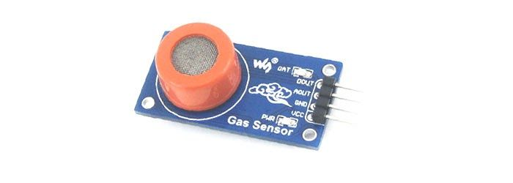

**How Mq3 sensor work:-**

When the presence of alcohol exist , then the sensor concentration increases.By increasing concentration output signal of gas concentration convert into charge of conductivity by using electronic circuits.

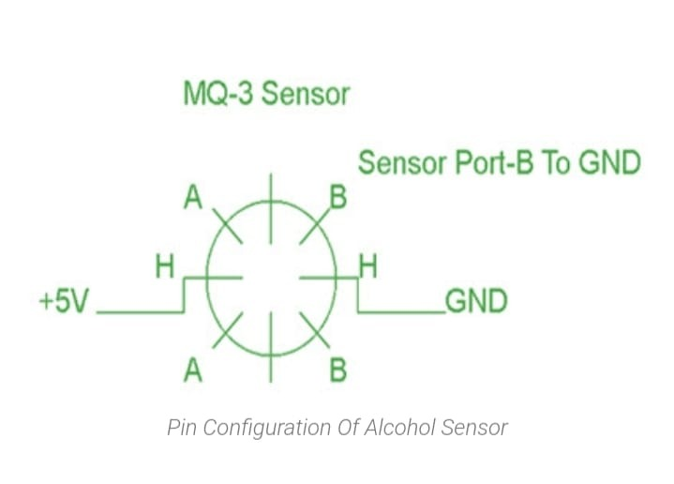

Receiving signal from PIR sensor to identify the presence of alcohol.If the alcohol is present then it show message that ”Sanitizer is good” otherwise it show ”Sanitizer is not good” on screen.

Mostly this sensor is used in vehicle alcohol detector or portable alcohol detector.It is stable and long life.

**Result analysis:**

This project is the need of the current on going scenario of COVID precaution by making device that help people to prevent themselves from the current disease(COVID-19). This device is work on real time and time to time update the user that, the user is safe or not.

Some Screen-shots of Code:-

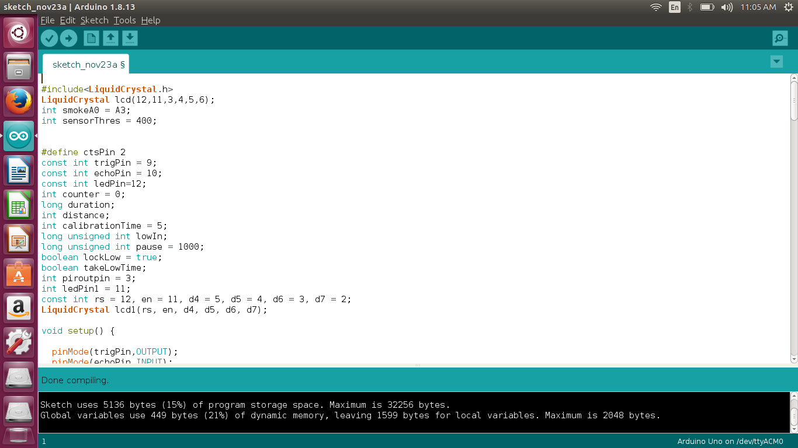

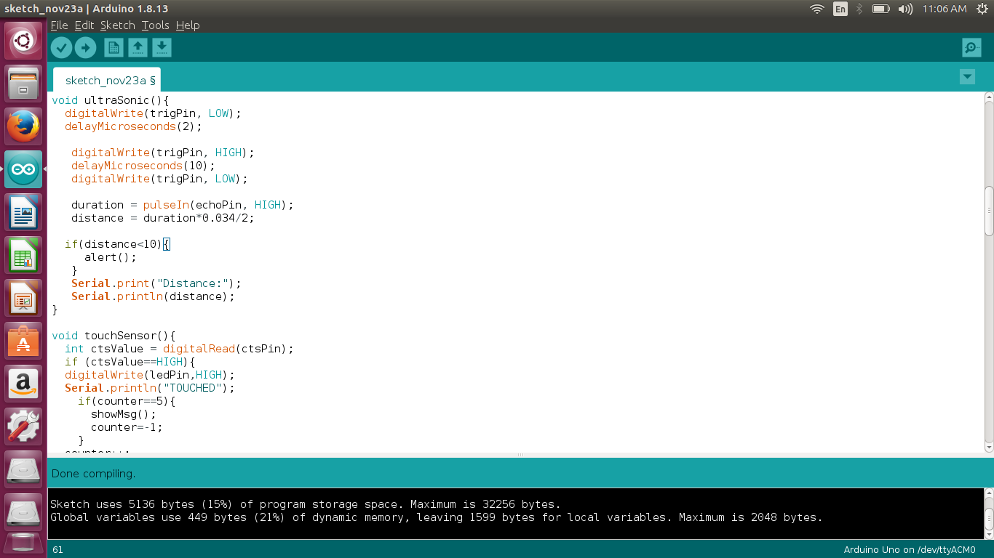

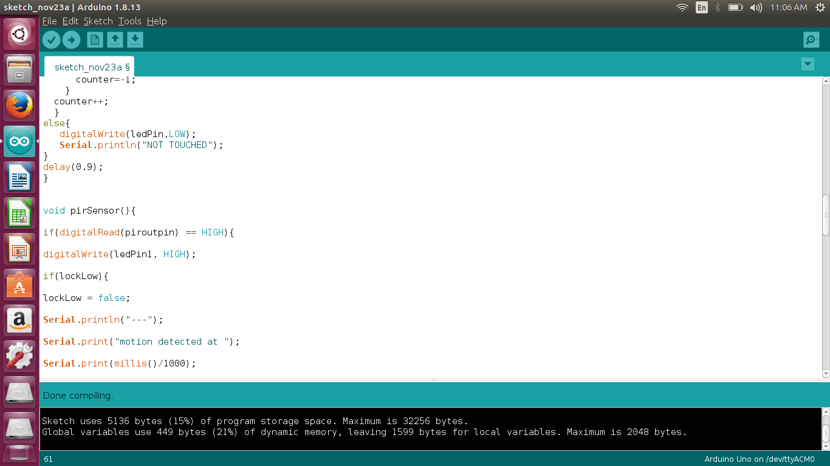

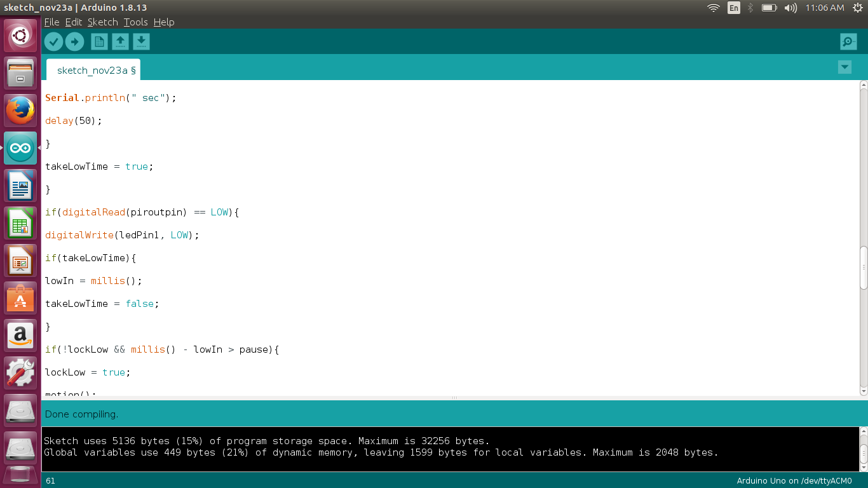

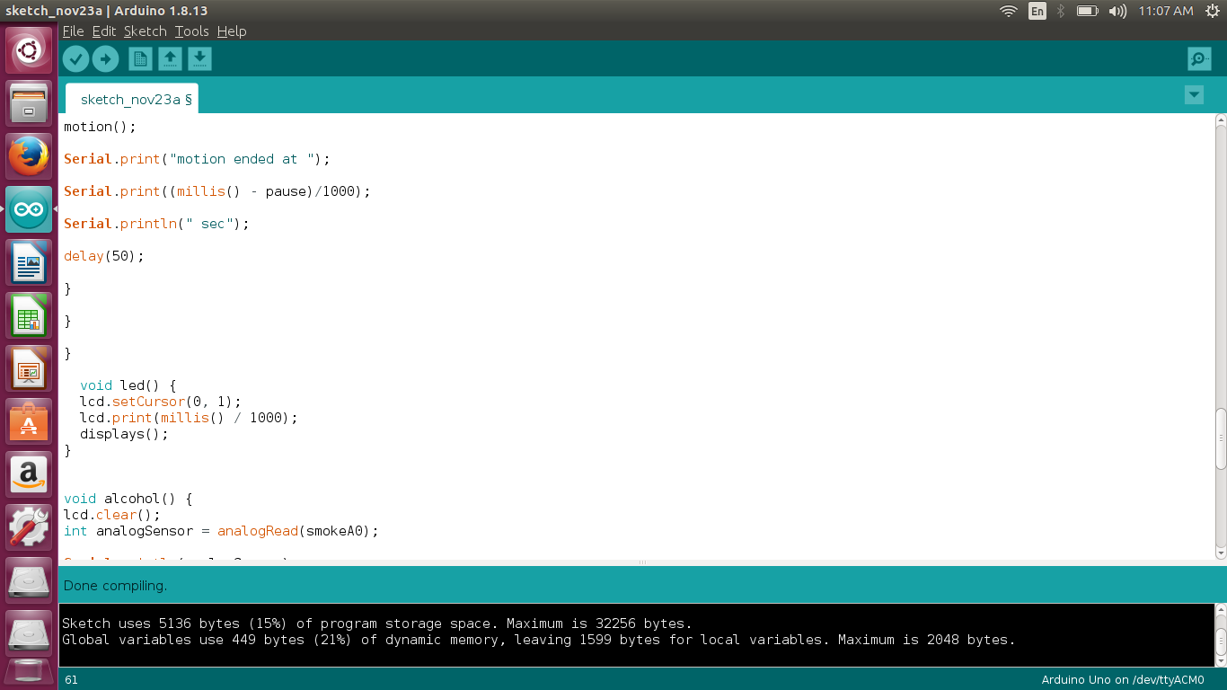

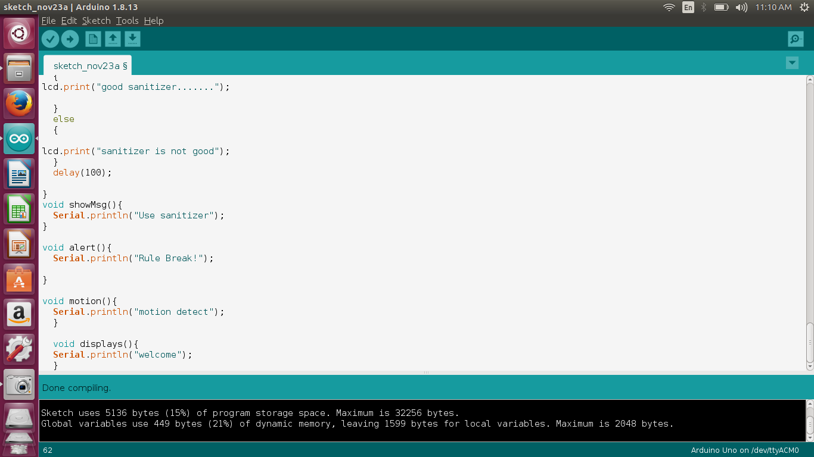

CODE:-

#include<LiquidCrystal.h>

LiquidCrystal lcd(12,11,3,4,5,6);

int smokeA0 = A3;

int sensorThres = 400;

#define ctsPin 2

const int trigPin = 9;

const int echoPin = 10;

const int ledPin=12;

int counter = 0;

long duration;

int distance;

int calibrationTime = 5;

long unsigned int lowIn;

long unsigned int pause =1000;

boolean lockLow = true;

boolean takeLowTime;

int piroutpin = 3;

int ledPin1 = 11;

const int rs = 12, en = 11, d4 = 5, d5 = 4, d6 = 3, d7 = 2;

LiquidCrystal lcd1(rs, en, d4, d5, d6, d7);

void setup()

{

pinMode(trigPin,OUTPUT);

pinMode(echoPin,INPUT);

pinMode(ledPin,OUTPUT);

pinMode(ctsPin,INPUT);

lcd.begin(16,2);

pinMode(smokeA0, INPUT);

lcd.begin(16, 2);

lcd.print("hello, world!");

Serial.begin(9600);

}

void loop()

{

ultraSonic();

touchSensor();

pirSensor();

led();

alcohol();

}

void ultraSonic()

{

digitalWrite(trigPin, LOW);

delayMicroseconds(2);

digitalWrite(trigPin, HIGH);

delayMicroseconds(10);

digitalWrite(trigPin, LOW);

duration = pulseIn(echoPin, HIGH);

distance = duration*0.034/2;

if(distance<10)

{

alert();

}

Serial.print("Distance:");

Serial.println(distance);

}

void touchSensor()

{

int ctsValue = digitalRead(ctsPin);

if (ctsValue==HIGH){

digitalWrite(ledPin,HIGH);

Serial.println("TOUCHED");

if(counter==5)

{

showMsg();

counter=-1;

}

counter++;

}

else

{

digitalWrite(ledPin,LOW);

Serial.println("NOT TOUCHED");

}

delay(0.9);

}

void pirSensor()

{

if(digitalRead(piroutpin) == HIGH)

{

digitalWrite(ledPin1, HIGH);

if(lockLow)

{

lockLow = false;

Serial.println("---");

Serial.print("motion detected at ");

Serial.print(millis()/1000);

Serial.println(" sec");

delay(50);

}

takeLowTime = true;

}

if(digitalRead(piroutpin) == LOW)

{

digitalWrite(ledPin1, LOW);

if(takeLowTime)

{

lowIn = millis();

takeLowTime = false;

}

if(!lockLow && millis() - lowIn > pause)

{

lockLow = true;

motion();

Serial.print("motion ended at ");

Serial.print((millis() - pause)/1000);

Serial.println(" sec");

delay(50);

}

}

}

void led()

{

lcd.setCursor(0, 1);

lcd.print(millis() / 1000);

displays();

}

void alcohol()

{

lcd.clear();

int analogSensor = analogRead(smokeA0);

Serial.println(analogSensor);

lcd.clear();

lcd.setCursor(0,0);

lcd.print("ALCOHOL DETECTOR");

lcd.setCursor(0,1);

if (analogSensor > sensorThres)

{

lcd.print("good sanitizer.......");

}

else

{

lcd.print("sanitizer is not good");

}

delay(100);

}

void showMsg()

{

Serial.println("Use sanitizer");

}

void alert()

{

Serial.println("Rule Break!");

}

void motion()

{

Serial.println("motion detect");

}

void displays()

{

Serial.println("welcome");

}

**REASON FOR SELECTING THIS PROJECT:**

The main reason is to select this project because current days COVID are rapidly increase day by day and we feel that is the best, easily understandable and relatable for now condition. Our second reason for selecting this is because now a days the IOT based gadgets are launched rapidly.That’s why we choose this type of project.

**Layout**

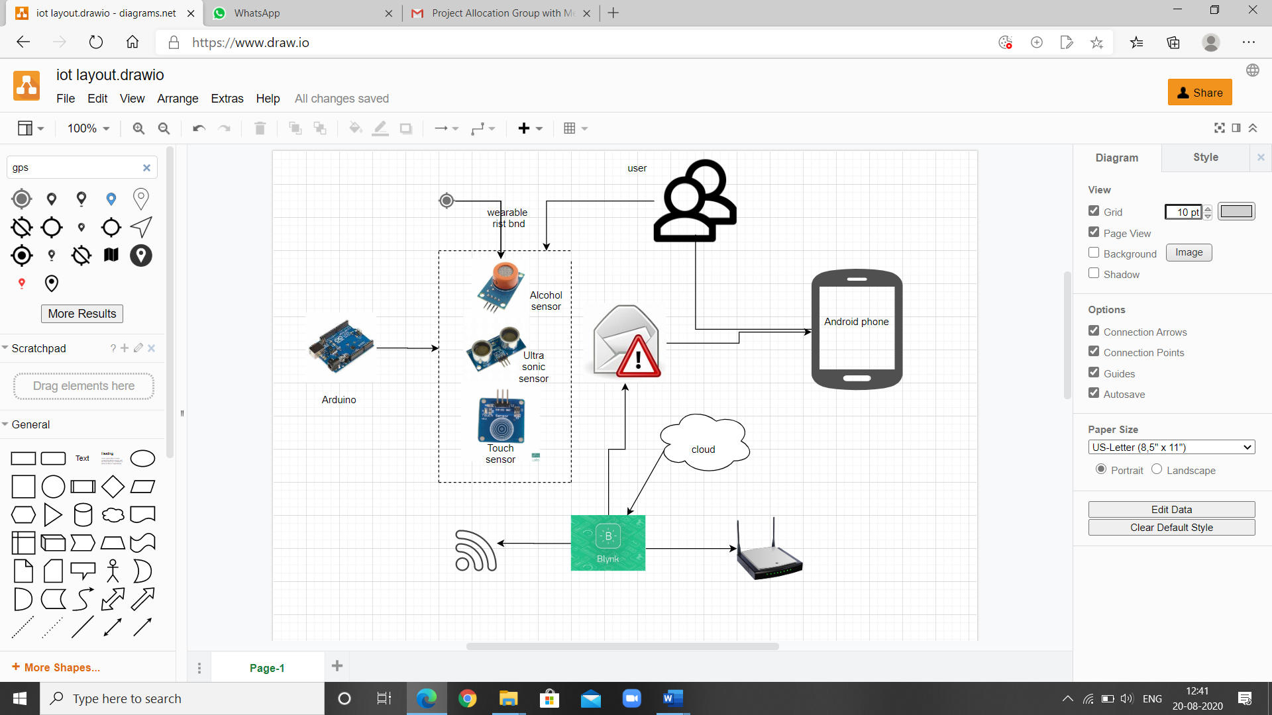

**References:**

1. Tutorial point
2. You tube

*Thank*

*You*